Numbers 20 The wages of sin is death

The background
Look at verse 1, 22-29 then compare it with Numbers 33:36-38, can you place the time and place in Israel’s journey in the wilderness?

If you can turn to Deuteronomy 1:3, then chapter 34; sketch out the timeline for the 3 leaders of Israel (Miriam, Aaron and Moses)

The issue
We are once again confronted with the complaints and grumblings of Israel. These they have done from Exodus 17 till this day. Please refresh your memory by reading Exodus 17:1-7

What was the charge against Moses in Exodus 17:3; Numbers 10:4, 5?

Compare the statement in Numbers 20:3 with Numbers 16:13 and 16:41; who are they identifying with? Is it logical or reasonable?

Look at verse 5b. Where do you think they last saw and tasted these things (grain, fig, vine, pomegranates)? [Clue: Numbers 13: 22-26]

Note: The same word used in Numbers 14:36, 37 “bad” report is used in Numbers 20:5 “evil” place. The former refers to the Promised Land which they rejected and the latter refers to the wilderness which they are in as a consequence of their choice.

So what is the real cause of their current predicament?

There are 2 typical behaviors that are amplified when we grumble and quarrel, we can see them both here:

Catastrophizing: painting our situation in far darker colors than is really warranted.

Question you may want to discuss:
- Is it really as bad as it is made out to be?
- Has God solved their problems before?
- Can God or will God do it again for the people of Israel?

Blame-shifting: Sin made us wanting to point to someone else as the reason for my failure. This is true right from the beginning when our first parents sinned. (See Genesis 3:12, 13)

Questions you may want to discuss:

- Why is it so difficult to see that it is our choices that led us into whatever problems we are facing?
- Have you been in such situations before when you are filled with anger and frustrations and are swallowed up with blames for someone else for your troubles? Would you share with your group how you overcome that? If you are still in such a place, perhaps you may want the whole group to pray with you on this matter.

Failure of Moses and Aaron

In Exodus 17, God provided and Moses acted on the instructions of the Lord to bring water out of the rock for the people. In Numbers 20:7-11, something else happened.

What was the instruction from God (verse 7, 8)? Was it different from the account in Exodus 17:6? Can you list the differences?

What did Moses do?

The good part (verse 9):

The bad part (verse 10-11):

What do you think was wrong in Moses statement in verse 10?

Discuss in your group as to the possible reasons for Moses’ and Aaron’s actions:

What is God’s verdict in verse 12?

“You did not believe Me” –

To trust in Yahweh means basically to find that he is worthy of reliance. In Num. 14, parallels to which have already been suggested, lō’-he’ĕmîn describes the rebellion of the Israelites, who, in spite of the many signs Yahweh had done in their midst, refused to rely on him to fulfill his further promises (see the commentary above on 14:11). Here Moses and Aaron succumb to the same sin; they have refused by their actions to rely on God to quench his people’s thirst without their aid in spite of all that he has done. They therefore disobeyed what God had commanded, culminating with Moses’ striking the rock twice. As the people had refused to rely on Yahweh in their first sojourn at Kadesh and were condemned to die outside the land of promise (14:11, 22–35), so here in the second sojourn there (many years later), the leaders make the same mistake and are sentenced to the same fate.

“To hallow (be set apart) Me in the eyes of the children of Israel” –

Yahweh’s second charge consists of an infinitive construct (l^{e}haqdîšēnî), which in this case shows an action consequent on the relying or trusting. The verb qāḏaš means “be set apart, consecrated, holy,” and in the Hiphil “to make separate, holy,” i.e., “to consecrate” or “treat as sacred.” Moses and Aaron have not treated Yahweh as sacred before the eyes of the children of Israel, i.e., openly, as they were commanded to do in v. 8 (“speak to the rock before their eyes”). Instead, by their lack of reliance on Yahweh, they have proved to be impediments to the manifestation of Yahweh’s power and holiness before the eyes of his people. When this happens, leaders of God’s people have lost their ability to lead.

Discuss in your group how you can practically live out these 2 aspects in your Christian life.

For the second judgment on Moses and Aaron not hallowing the Lord, in what ways do you think Church leaders ought to demonstrate this (I may ask your group to present your views)?

Dealing with Edom

Look through Numbers 20: 14-21; can you figure out one thing that is conspicuously absent in this passage? (Compare to Numbers 21: 1-3)

Look at the map provided:

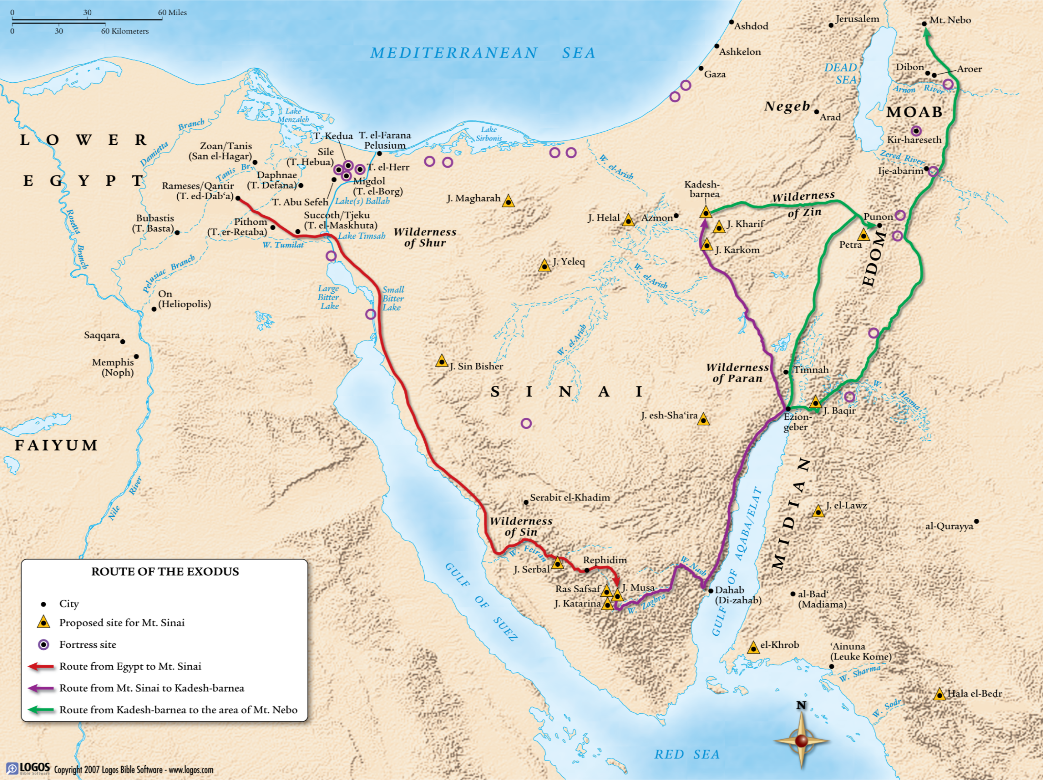
What do you think Moses is trying to do in dealing with Edom?

What were the result of the negotiation?

Why do you think this account is provided here in Numbers 20? What lesson does it hold for us as believers in the 21st century?

Death of Aaron

The chapter started with the death of Miriam and ends with the death of Aaron. It signals the beginning of the end of the first generation (Moses was to die some time later as given in Deuteronomy 33). The death of Aaron (and later Moses) is foretold by the verdict of the judgment of God in Numbers 20:12.

What was the reason given for the death of Aaron (verse 24)?

Apart from not being allowed to enter into the Promised Land, what other demonstrated judgment fall upon Aaron (verse 25, 26)?

What do you think the term “strip” connotes?

Cross reference to Hebrews 7:23-25; how does the death of Aaron tells us about our mediator between God and man? Does it help you to see Christ as more precious?

Moses looking back at this journey in Psalm 90. The conclusion for the generation can be gleamed from verses 5-9:

You sweep them away as with a flood; they are like a dream,
Like grass that is renewed in the morning:
In the morning it flourishes and is renewed;
In the evening it fades and withers.
For we are brought to an end by your anger;
By your wrath we are dismayed.
You have set our iniquities before you,
Our secret sins in the light of your presence.
For all our days pass away under your wrath;
We bring our years to an end like a sigh.

Discuss in your group the primary danger for the Israelites. Is it water, food, wilderness afflictions?)

(Look at the assessment from Hebrews 4:1-5 and the warning in verse 6.)

The wages of sin is death and the conclusion in this chapter bore out that truth. Even

Miriam
- Can you picture her work in ensuring baby Moses gets a Godly mother to train him in the truth about Yahweh? Or
- Can you hear her songs in Exodus 15:20
Aaron
- Being Moses faithful companion in the call to Pharaoh?
- Being the High Priest for Israel with his rod flowering with Almond blossom?
Moses
- Described to be the meekest man
- Described as the faithful servant in God’s household
- All the miracles and wonders that is done through him for all Israel

“ Nevertheless death reigned from Adam to Moses, even over those who had not sinned according to the likeness of the transgression of Adam, who is a type of Him who was to come.”
Romans 5:14

But Moses is not meant to be our savior! And Aaron not to be our High Priest!

In the account of both Exodus 17 and Numbers 20, Paul interpreting on the OT says:

“ For they drank of that spiritual Rock that followed them, and that Rock was Christ. “
1 Corinthians 10:4b

Christ was that rock. Jesus Christ (who is God himself) took the blows that we deserve for our rebellion. He is the righteous High Priest who was stripped not because of any failure on his part but to enable him to take our place on the cross under God’s curse. From him flows the living water that we need to slake our thirsty souls and to transform our lives increasingly into his image.

Like Moses and Aaron, we are all rebels who deserves death. Yet in Christ there is an answer for our rebellion. In Christ we have someone who has taken the death that we deserved and has paid fully for our sins. His perfect obedience is now credited to our account exactly as if it were our own. In him we are justified freely right now, sinners though we are. In that reality lies our hope, our peace and our comfort in the weary wilderness.

Numbers (Preaching the Word Series) by Ian M. Duguid with R. Kent Hughes as general editor, pp251
Ashley, T. R. (1993). The Book of Numbers (pp. 385–386). Grand Rapids, MI: Wm. B. Eerdmans Publishing Co.
Ashley, T. R. (1993). The Book of Numbers (p. 386). Grand Rapids, MI: Wm. B. Eerdmans Publishing Co.
Numbers (Preaching the word series) by Iain Duguid, edited by R. Kent Hughes pp 258

